Data Models

Business Rules:
- A USER has many ROLES.
- A USER has one BIRTHDATE.
- A USER can have many DEPENDENTS.

Entity-Relationship Diagram:
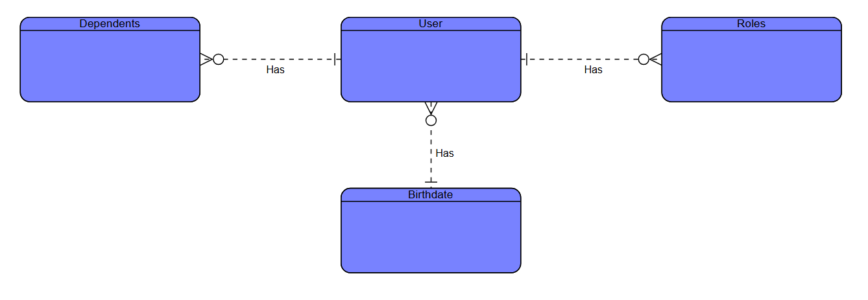

NoSQL Data Structure (Diagram):
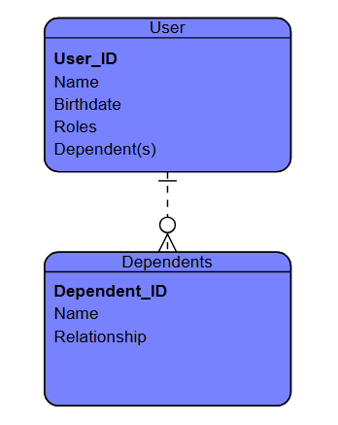
NoSQL Data Structure (JSON):
{
"user_id": "ab1234",
"first_name": "Anne",
"last_name": "Barton",
"birthdate": "06-17-1995",
"roles": ["manager", "user"],
"dependents":
{
"name": "Caleb Donald",
"relationship": "spouse"
},
{
"name": "Emmett Barton",
"relationship": "child"
}
]
}

